
Sukkur Institute of Business Administration University Department of Computer Science

Object oriented programming in Java BS – II Spring-2025

Lab # 04
Unveiling the World of Classes and Objects, Delving into the Depths of String and Array Manipulation

Instructor: Nimra Mughal
Section BSCS Ai-B
Submitted By: Azhar Ali Soomro
CMS: 023-24-0521

Exercises
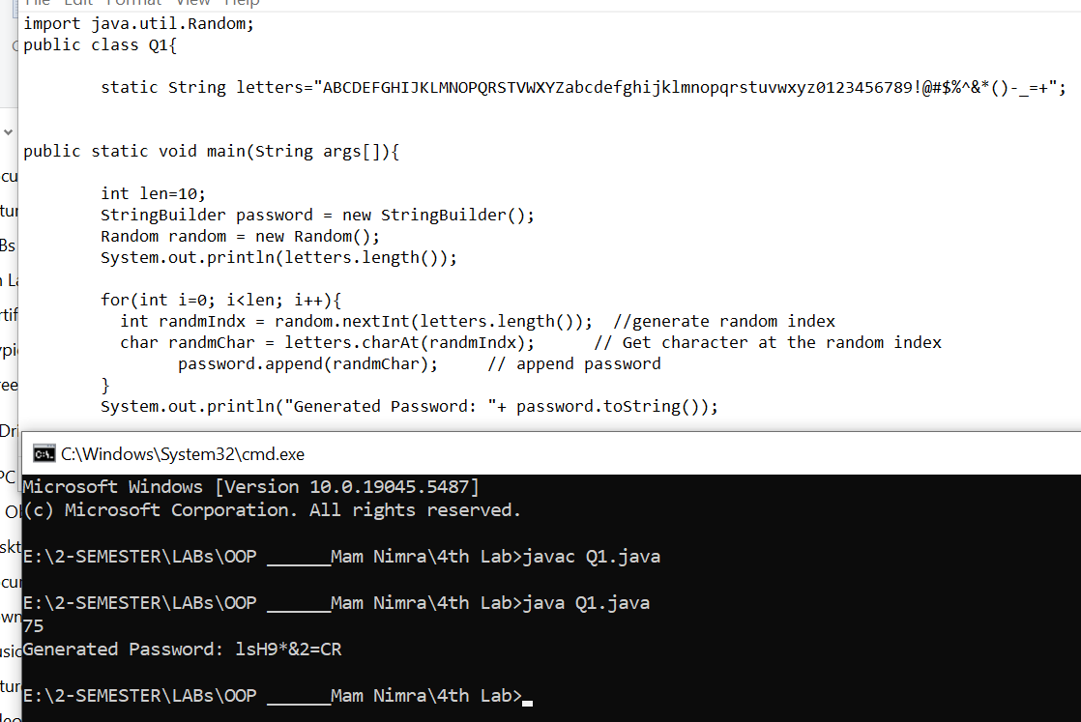
1. Generate random passwords: Write a code that generates a random password of a specified length, using a combination of letters, numbers, and symbols.
2. Create a class Person with fields for name, age, and address.
• Use @author and @version tags in the class comment.
• Format comments with HTML tags for emphasis and lists (e.g., ).

